**Lab -11( Exceptions)**

1. **Write a Python program to handle a ZeroDivisionError exception when dividing a number by zero.**

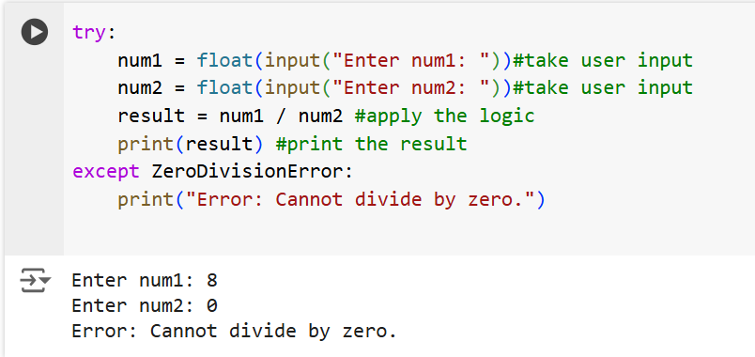

1. **Write a Python program that prompts the user to input an integer and raises a ValueError exception if the input is not a valid integer.**

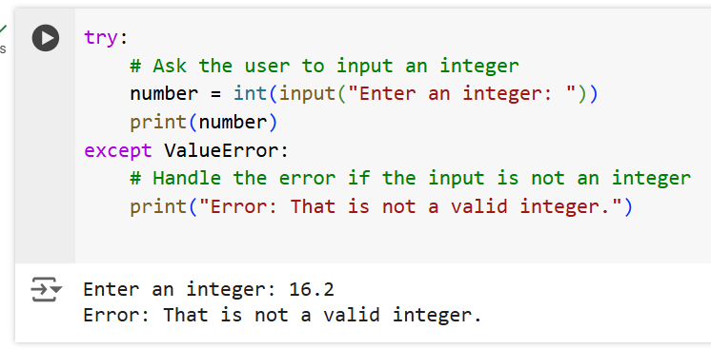

1. **Write a Python program that opens a file and handles a FileNotFoundError exception if the file does not exist.**

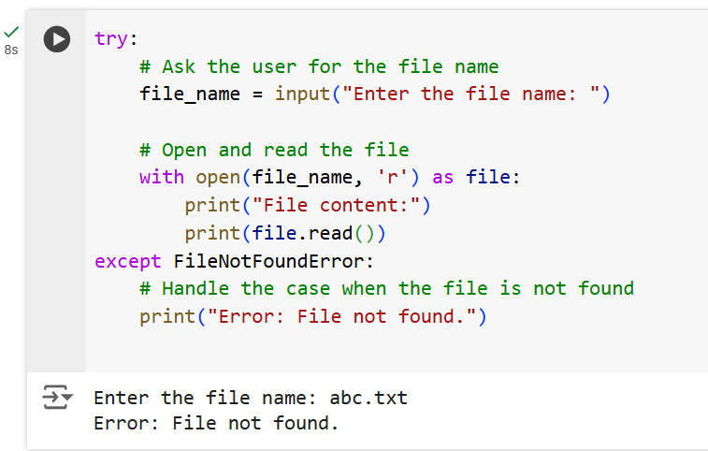

1. **Write a Python program that prompts the user to input two numbers and raises a TypeError exception if the inputs are not numerical.**

